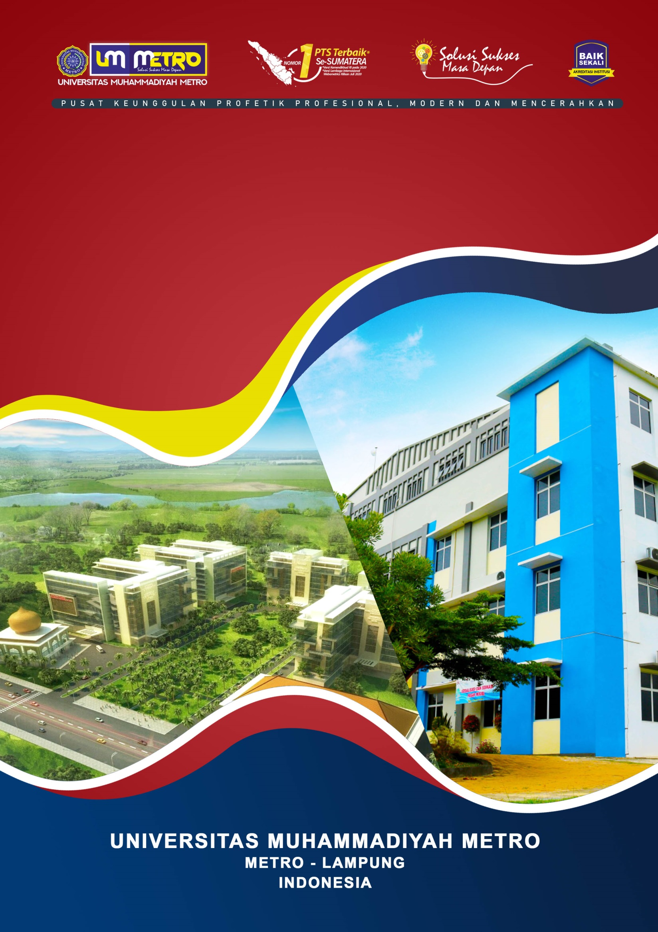
FOOD SAFETY WORKSHOP

FOOD SAFETY FIELD PRACTICE PROGRAM OF POSTGRADUATE PROGRAM
https://pascasarjana.ummetro.ac.id/

Objective
Environmental pollution from chemicals is an issue that is still hot to be discussed; the decline in environmental quality as a result of the impact of using chemicals makes the environment a source of pollutants and toxins for humans. Detection of contaminants such as heavy metals is an anticipation effort to degrade the entry of pollutant substances into the body.
This program aims to provide opportunities for students to increase knowledge about food safety field practice on how to detect heavy metals in a simple way in the aquatic and agricultural environment of Metro City in Indonesia.
The practice of simple detection is studied with relevant theories about heavy metals, which is strengthened by a forum for discussion and transfer of knowledge through PPUPIK Corporation, which examines more deeply about environmental pollution.
Receiver
The benefits of this practice program can make students aware of the dangers of heavy metals that are starting to pollute the surrounding environment and the importance of making students aware of protecting the environment.
Participant
This practical program is intended for postgraduate students (master's level) in biology education classes, especially bioremediation classes. We combine theory and practice of bioremediation in detecting heavy metals in the environment.
Passive English skills have been able to participate in this training and will still be directed by the lecturer.
Facilities Obtained
Students who take this short course can get a certificate to detect heavy metals in waters.
The students will be given short course material.

Activity
This program offers thirteen meetings, theory, and field practice to waterfront areas on the outskirts of the countryside.
FIELD PRACTICE PROGRAM
FOOD SAFETY AND SIMPLE DETECTION OF HEAVY METALS IN THE ENVIRONMENT
No | Day | Topic | Method | Presenter
1 | I (8 hours) | Why food must be safe | Discussion and Q&A | Dr.Achyani, M.Si.  Dr. Agus Sujarwanta, M.Pd.
2 | II (8 hours) | Halalan Thoyiban, how is the application? | Discussion and Q&A | Dr.Samson Fajar, M.Pd.I.
3 | III (8 hours) | The healthy practice of plant cultivation | Discussion and Q&A | Dr. Agus Sutanto, M.Si.  Dr. Handoko Santoso,M.Pd.
4 | IV (8 hours) | Environmental pollution | Discussion and Q&A | Dr.Hening Widowati,M.Si.  Dr.Muhfahroyin,M.TA.
5 | V (8 hours) | Water pollution and food safety | Discussion and Q&A | Dr.Hening Widowati,M.Si.  Ade Gunawan, M.Pd.
6 | VI (8 hours) | Soil pollution and food safety | Discussion, Q&A, and practice | Dr.Hening Widowati,M.Si.  Mia Cholvistaria, M.Pd.
7 | VII (8 hours) | Utilization of Waste for Fertilizer | Discussion, Q&A, and practice | Dr. Agus Sutanto, M, Si.  Beny Saputro,M.Pd.
8 | VIII-IX(8 hours) | A visit to eco-friendly waters | Discussion, Q&A, and practice | Tim
9. | X-XI (8 hours) | A visit to an eco-friendly plantation | Discussion, Q&A, and practice | Team
10. | XII-XIII (8 hours) | Kopi Luwak (Civet Coffee), a healthy drink native to Lampung | Discussion and Q&A | Nedi Hendi, M.M.  Feny Thresia,M.Pd.
11 | XII (2 hours) | Post-test | CBT | Team

